

**KULLIYYAH OF ENGINEERING (KOE)**

**MECHATRONICS SYSTEM INTEGRATION (MCTA3203)**

**SEMESTER 2, 23/24**

**SECTION 1**

**PROJECT REPORT WEEK 2**

**TITLE : DIGITAL LOGIC SYSTEM**

**PREPARED BY :**

|  |  |  |
| --- | --- | --- |
| NO | NAME | MATRIC NO |
| 1 | AMIRAH HUDA BINTI JAMALULAIL ASRI | 2210776 |
| 2 | DAMIA MAISARAH BINTI ZAWAWI | 2217830 |
| 3 | NUR SHADATUL BALQISH BINTI SHAHRUNIZAM | 2212064 |

**DATE OF SUBMISSION :**

**20 MARCH 2024**

**ABSTRACT**

This report presents an experiment utilizing an Arduino Uno, pushbuttons, and a common cathode 7-segment display to illustrate the creation of a digital counter. By integrating hardware configuration and software execution, the methodology enhances practical skills in component integration, Arduino programming, and circuitry. The study investigates the efficacy of the Arduino platform in facilitating hands-on electronics learning. It encompasses the experimental setup, approach, process, findings, discussion, and conclusion. Furthermore, the report delves into the amalgamation of coding concepts for the 7-segment display and matrix LED, coupled with connecting an I2C LCD to an Arduino, emphasizing simplified wiring and reduced pin requirements. Additionally, it addresses hardware, electrical, and software issues, such as wiring complications and push button debounce, providing resolutions. Suggestions for future enhancements are also outlined.

|  |  |  |
| --- | --- | --- |
| NO | TOPIC | PAGE |
| 1 | INTRODUCTION | 2 |
| 2 | MATERIALS AND EQUIPMENTS | 2 |
| 3 | EXPERIMENT SETUP | 3-4 |
| 4 | PROCEDURES | 4 |
| 5 | RESULTS | 5 |
| 6 | DISCUSSIONS | 6-7 |
| 7 | CONCLUSION | 8 |
| 8 | RECOMMENDATIONS | 8-9 |
| 9 | ACKNOWLEDGEMENT | 9 |
| 10 | STUDENTS’S DECLARATION | 10 |

TABLE OF CONTENTS

**INTRODUCTION**

This experiment aimed to demonstrate how a common cathode 7-segment display and pushbuttons can be interfaced with an Arduino Uno to create a digital counter. By combining hardware setup with Arduino programming, participants were expected to gain practical knowledge in circuitry, Arduino programming, and component integration**.**

**MATERIALS AND EQUIPMENTS :**

* Arduino Uno board
* Common cathode 7-segment display
* 220-ohm resistors (7 of them)
* Pushbuttons (2 or more)
* Jumper wires
* Breadboard

**EXPERIMENTS SETUP**

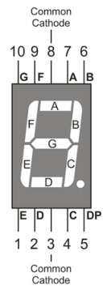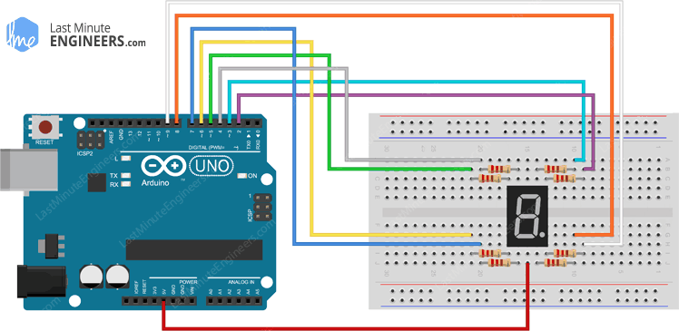

1. Connect the common cathode 7-segment display to the Arduino Uno as follows:

* Connect each of the 7 segments (a, b, c, d, e, f, g) of the display to separate digital pins on the Arduino (e.g., D0 to D6).
* Connect the common cathode pin of the display to one of the GND (ground) pins on the Arduino.
* Use 220-ohm resistors to connect each of the segment pins to the Arduino pins to limit the current.

1. Connect the pushbuttons to the Arduino:

* Connect one leg of each pushbutton to a separate digital pin (e.g., D9 and D10) and connect the other leg of each pushbutton to GND.
* Use 10K-ohm pull-up resistors for each pushbutton by connecting one end of each resistor to the digital pin and the other end to the 5V output of the Arduino.

**PROCEDURES**

1. Build the circuit according to the circuit setup instructions.
2. Upload the provided Arduino code to your Arduino Uno.
3. Open the Serial Monitor in the Arduino IDE.
4. Press the increment button to increase the count. The 7-segment display should show the numbers from 0 to 9 sequentially.
5. Press the reset button to reset the count to 0.

**RESULTS**

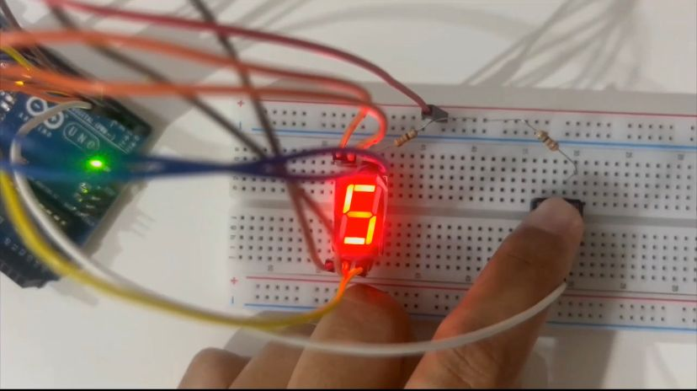

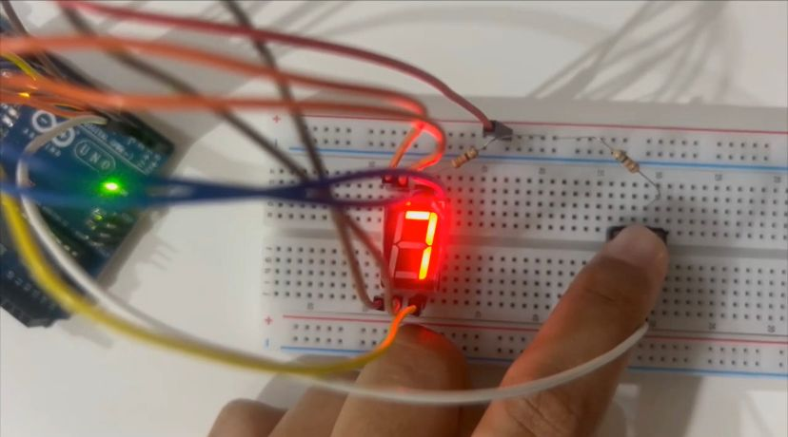

**DISCUSSIONS**

* **Software**

The Arduino software simplifies programming microcontrollers by offering a user-friendly interface for writing, building, and uploading code. This open-source platform features a text editor, a toolbar with common actions, and various menus providing access to examples, libraries, and tools. Developers use the C/C++ programming language to write code that is then compiled and uploaded to Arduino boards, enabling them to control the microcontroller's behavior and create a wide range of interactive projects.

* **Electrical**

The 7-segment display and push button, both coupled to the Arduino Mega 2560, are the project's main electrical components. To adjust brightness and safeguard the LEDs on the 7-segment display, current-limiting resistors are required for each segment. Furthermore, the display's common cathode and anode must be connected to the necessary Arduino pins for digit selection and data transfer. A pull-up or pull-down resistor is used on the push button to ensure steady voltage levels while not in use and to prevent floating inputs. Reliable operation and precise counting need proper breadboard wiring, which includes correct connections and resistor values. Understanding each component's voltage and current requirements assures compatibility and protects the Arduino and its components.

* **Hardware**

The digital counter system built using an Arduino Mega 2560, a 7-segment display, and a push button, operates with the Arduino managing the counting process. Each press of the push button increments the displayed number. The components are interconnected via male-to-male jumper wires on a breadboard to ensure accurate wiring and optimal functionality. The system's logic relies on the Arduino's digital input/output pins to interact with the push button for input detection and the 7-segment display for number presentation. The project addresses challenges such as push button debounce and wiring errors, offering solutions to mitigate these issues. Furthermore, the project explores possibilities for improvement, including the addition of a reset function and the expansion to support multiple-digit counters, which would enhance the system's capabilities and provide deeper insights into microcontroller interfacing, digital electronics, and embedded systems.

**Questions:**

How to interface an I2C LCD with Arduino? Explain the coding principle behind it compared with 7 segments display and matrix LED.

**Answers :**

* Connect the I2C LCD and Arduino boards together. This commonly comprises connecting the LCD's SDA pin to the Arduino's A4 pin and the SCL pin to the Arduino's A5 pin. Verify that the Arduino's proper power and ground pins are connected to the LCD's VCC and GND pins.
* Interfacing with an I2C LCD is generally easier compared to both 7-segment displays and matrix LEDs because it abstracts much of the low-level communication and control, allowing you to focus more on the application logic.

**Matrix LED**: Matrix LEDs require multiplexing to control several LEDs. You must control rows and columns to turn on specified LEDs at precise locations. While libraries can make this process easier, it still requires more complicated code than the I2C LCD.

**7-Segment Display**: Interfacing with a 7-segment display frequently involves directly manipulating the individual segments via digital output pins. You must manually control which parts are turned on and off to show the desired letters or numbers. This necessitates more code and hardware knowledge.

**CONCLUSION**

In conclusion, the experiment revealed the Arduino platform's exceptional ability to promote experiential learning in electronics education. By seamlessly merging hardware setup and programming, participants were able to engage in a hands-on examination of key topics including circuits and microcontroller interface. The successful building of a digital counter demonstrated the approach's usefulness in enabling practical knowledge acquisition.The project not only accomplished its aims, but also provided useful insights on the use of Arduino in educational settings. It demonstrated the platform's ability to democratise access to electronics education by offering a simple yet effective tool for both students and educators.

**RECOMMENDATIONS**

1. Emphasise the real-world applications of digital logic systems throughout the experiment. Discuss how digital logic concepts are applied in a variety of technologies and businesses, including computer architecture, telecommunications, and digital signal processing.

2. Include problem-solving exercises in the experiment to test students' critical thinking and problem-solving abilities. Give them real-world scenarios or design issues that necessitate the use of digital logic concepts to discover answers.

3. Include reflection and synthesis activities at the end of the experiment, allowing students to reflect on their learning experiences, relate the experiment to larger ideas, and synthesise their understanding of digital logic systems.

**ACKNOWLEDGEMENT**

We would like to express our gratitude to Dr. Wahju Sediono, Dr. Ali Sophian, Dr. Zulkifli Bin Zainal Abidin, for providing the necessary resources and facilities to conduct this and support throughout the duration of the project. Additionally, we extend our appreciation to all individuals who contributed to the success of this lab report through their valuable insights and feedback.

**STUDENT’S DECLARATION**

**Certificate of Originality and Authenticity**

This is to certify that we are responsible for the work submitted in this report, that **the original work** is our own except as specified in the references and acknowledgement, and that the original work contained herein have not been untaken or done by unspecified sources or persons.

We hereby certify that this report has **not been done by only one individual** and **all of us have contributed to the report**. The length of contribution to the reports by each individual is noted within this certificate.

We also hereby certify that we have **read** and **understand** the content of the total report and that no further improvement on the reports is needed from any of the individual contributors to the report.

We, therefore, agreed unanimously that this report shall be submitted for **marking** and this **final printed report** has been **verified by us.**

|  |  |  |
| --- | --- | --- |
| **Signature:** | **Read** | **/** |
| **Name:** Amirah Huda Binti Jamalullail Asri ……………………………………..…………. | **Understand** | **/** |
| **Matric No:** 2210776 | **Agree** | **/** |

|  |  |  |
| --- | --- | --- |
| **Signature:** | **Read** | **/** |
| **Name:** Damia Maisarah Binti Zawawi ……….. | **Understand** | **/** |
| **Matric No:**2217830 | **Agree** | **/** |

|  |  |  |
| --- | --- | --- |
| **Signature:** | **Read** | **/** |
| **Name:** Nur Shadatul Blaqish Binti Sharunizam | **Understand** | **/** |
| **Matric No:** 2212064 | **Agree** | **/** |